# CS 255 System Design Document

Michael Duclos

## UML Diagrams

### UML Use Case Diagram

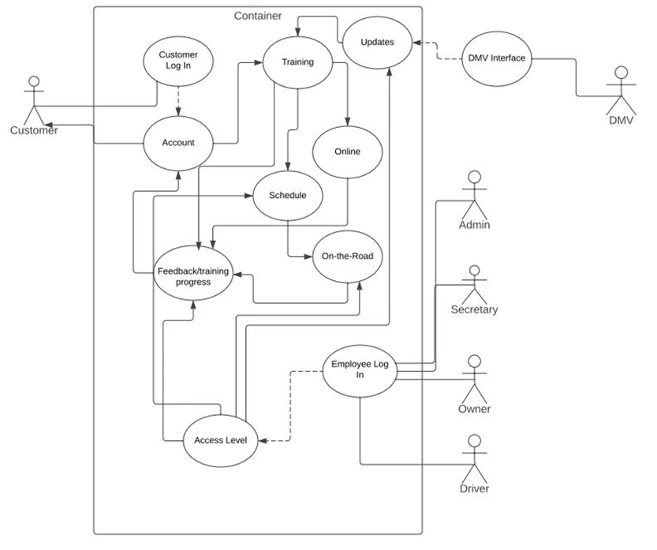

**Activity Diagram for Online Training:**

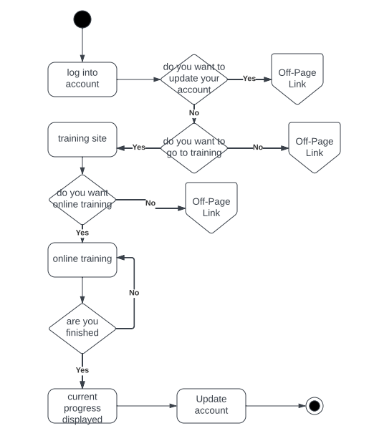

**Activity Diagram for Driving Instructor**

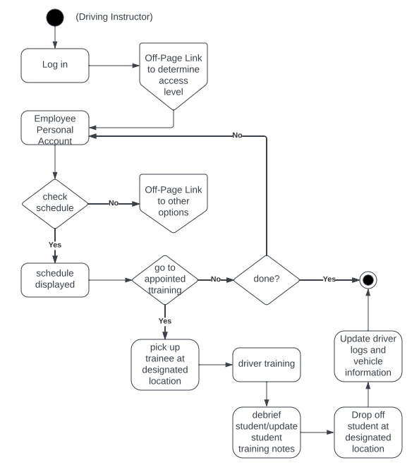

### UML Sequence Diagram

**Sequence Diagram for Customer Online Training**

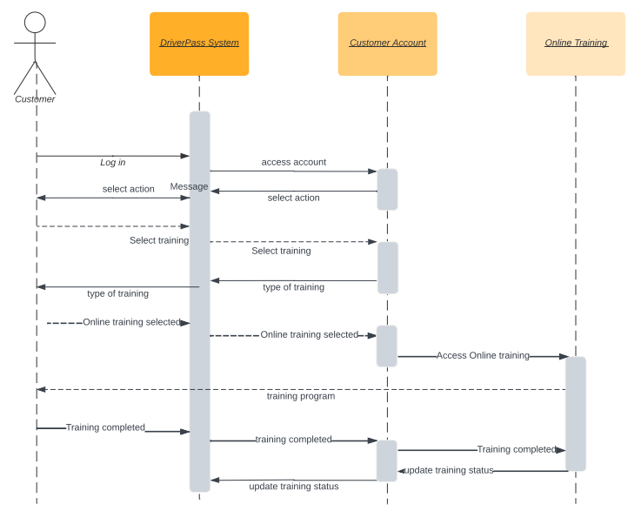

### UML Class Diagram

**UML Class Diagram for DriverPass**

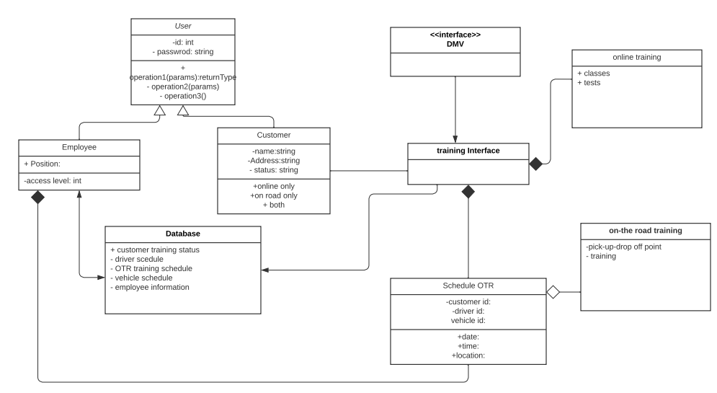

## Technical Requirements

(Spacey, 2021)

**Availability:** The system will maintain availability of 99%.

**Reliability:** The system will maintain a mean time between failures of greater than 60 days.

**Performance:** system will have an average load time of less than 2 seconds.

**Information Security:** user credentials and all personally identifiable information (PII) will be encrypted in storage and transit.

**Interoperability:** The website will work on all major operating systems, devices, and browsers as specified by customer requirements.

**Serviceability:** Changes and upgrades to the system will not require total outages.

**Standards:** The system will comply with standard architectural and security requirements.

**Authentication and Authorization:** The system will conform to DriverPass’s policy for authentication and authorization.

**Citations:**

Spacey, John. “25 Examples of Technical Requirements.” *Simplicable*, 2 May 2021, https://simplicable.com/en/technical-requirements.